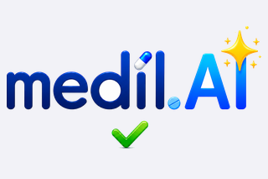 | Medil AI Patient Guide  Search medications, build your personal list, schedule doses, and follow your health diary. |   Scan to open medil.ai

AI-assisted prescription OCR can be performed, but results must be validated. In this short guide we show how the workflow can be performed manually, which is the most reliable method to enter a prescription.

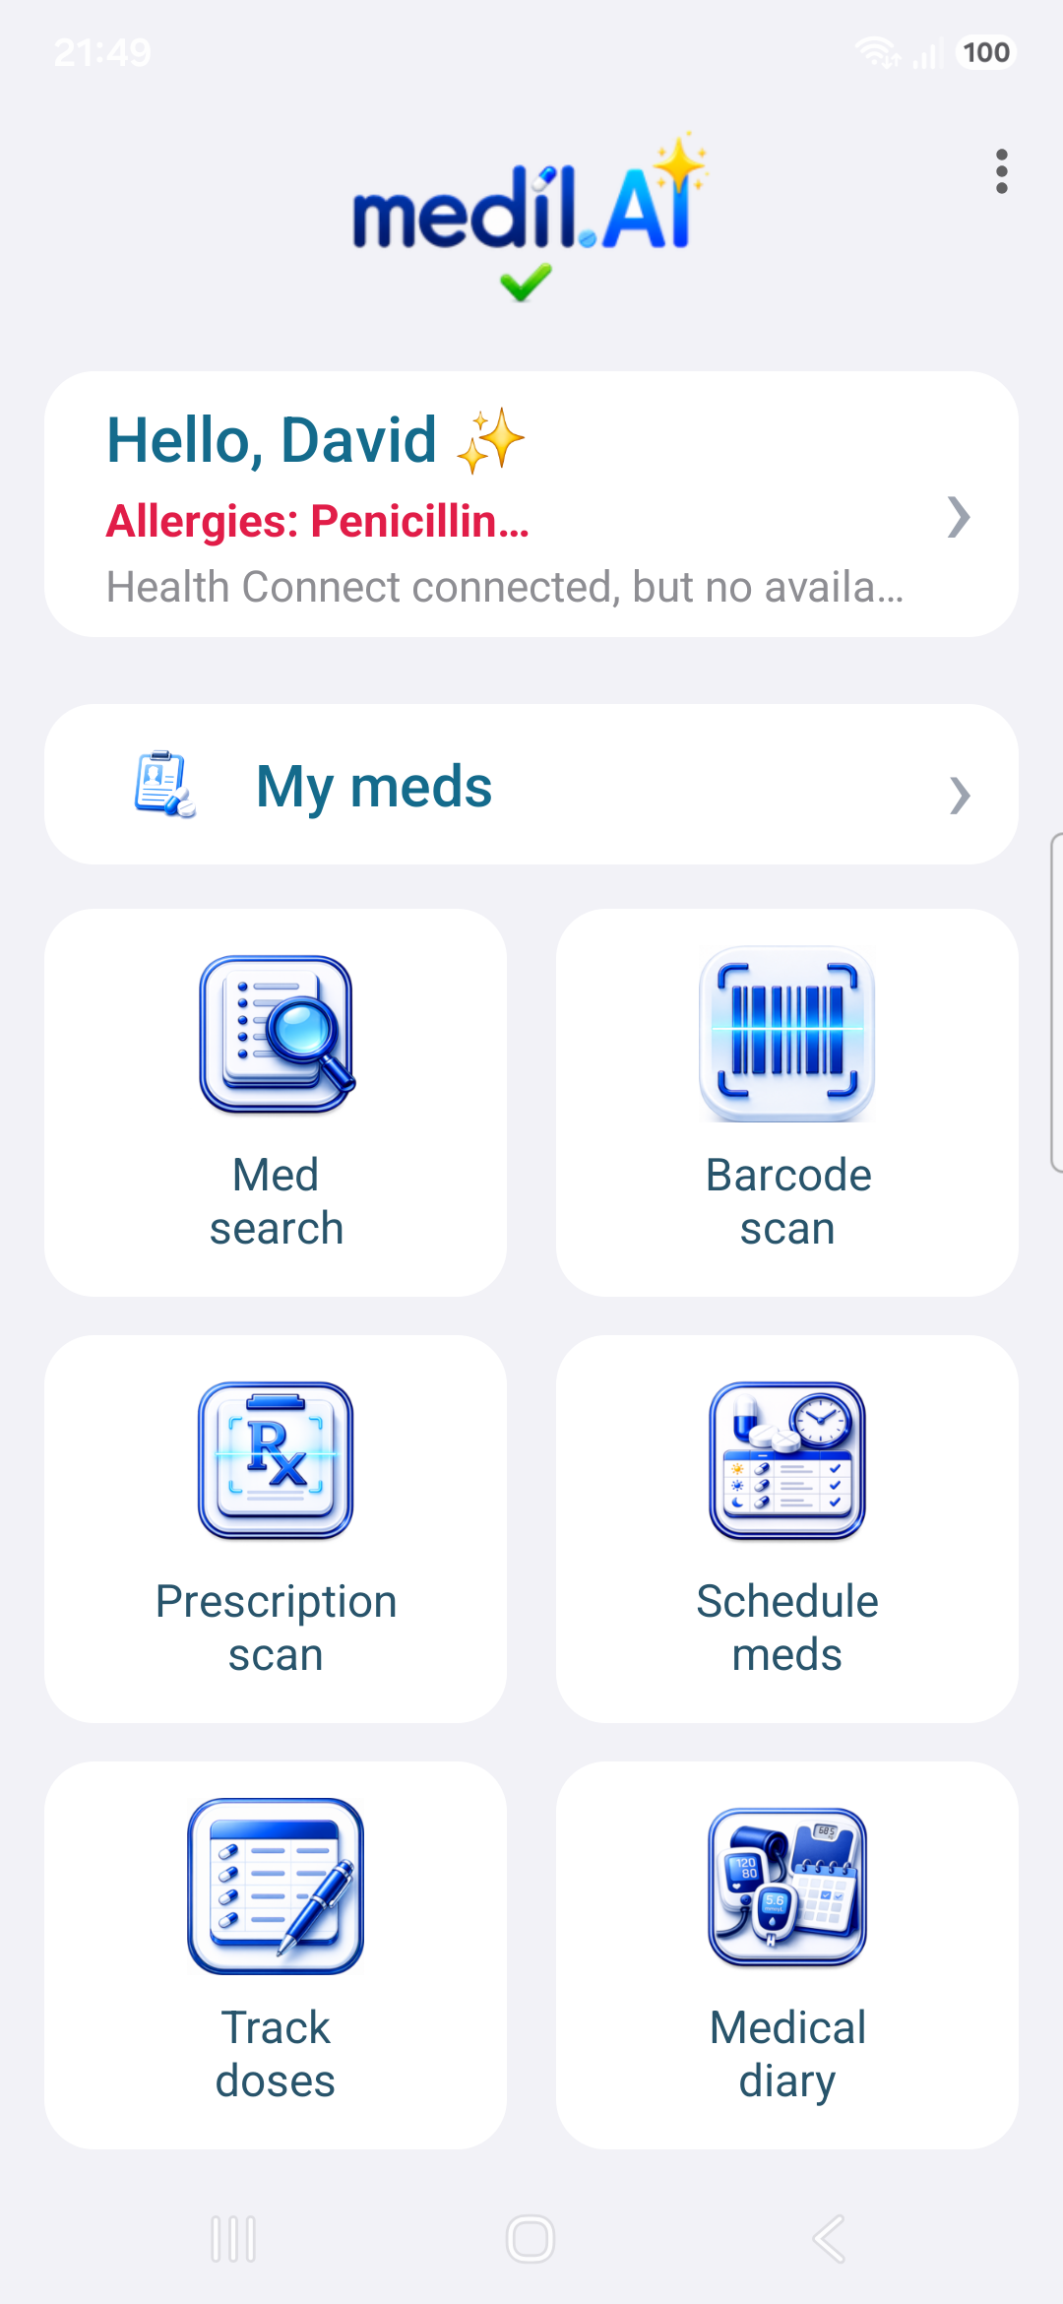 | 1. Start from the home screen  The home screen gives direct access to search, barcode scan, My Meds, prescription scan, scheduling, tracking, and the medical diary.

2. Switch brand and dosage  Two selectors at the top of the page keep you oriented: the upper one lists the commercial names available for this medication family, the lower one the dosages of the selected brand. The example shows Micropirin 75 mg and 100 mg. | 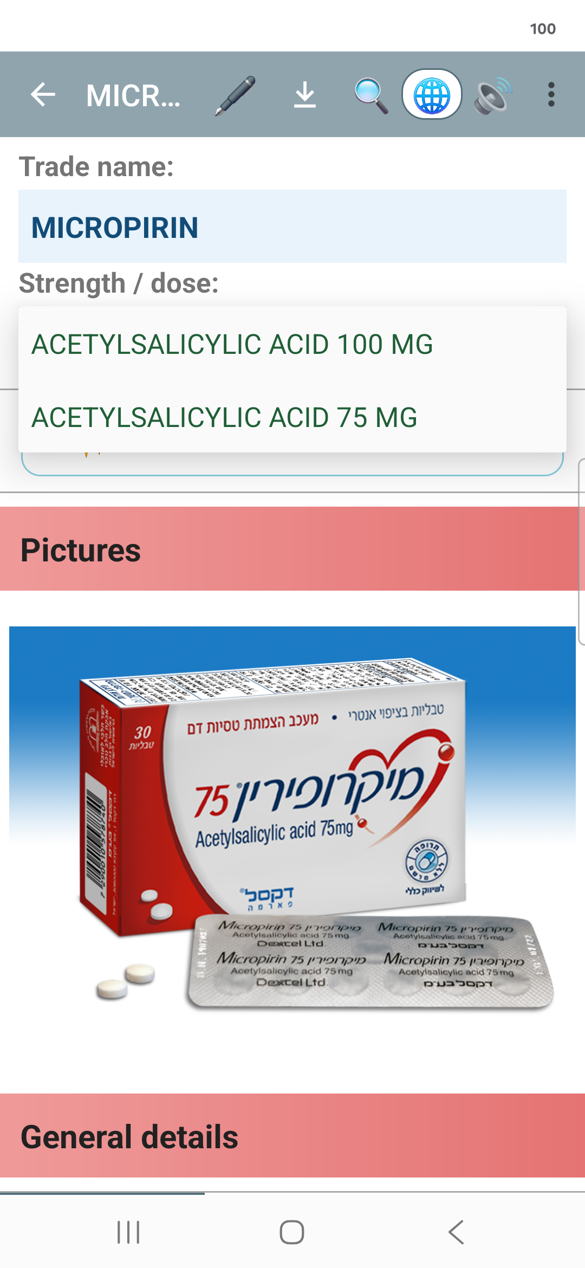

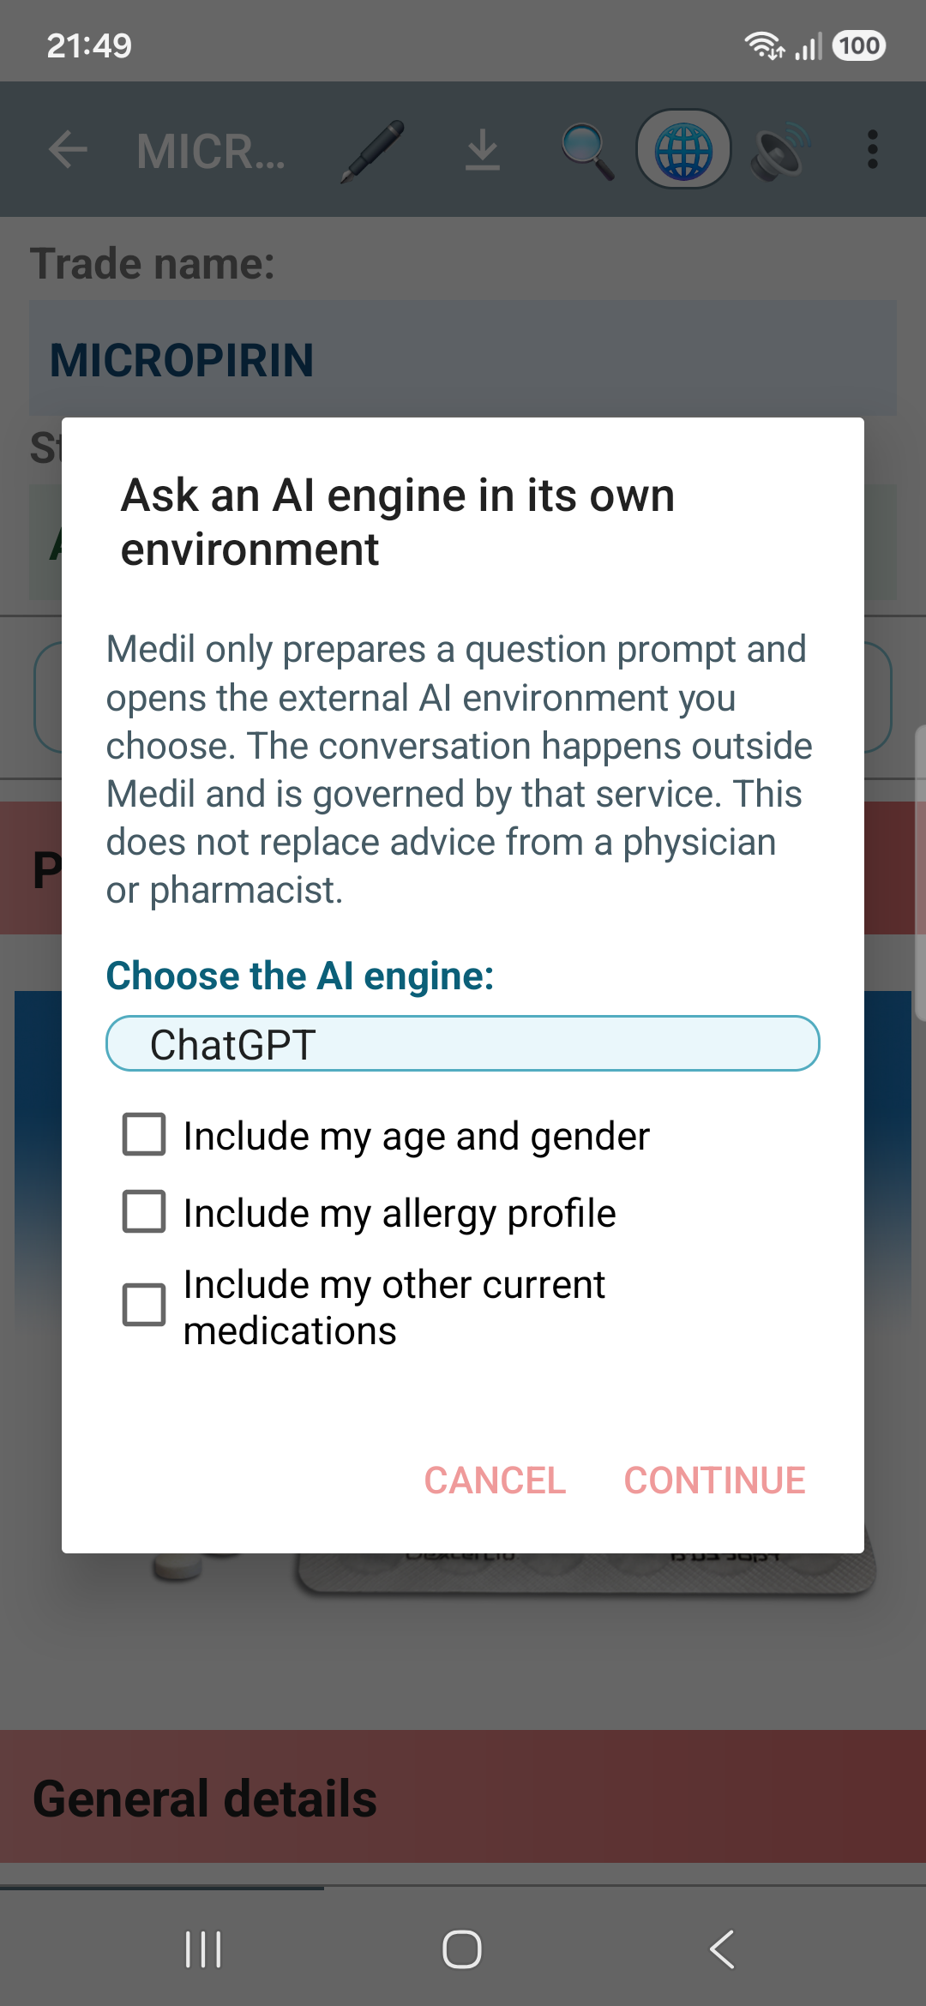 | 3. Ask an AI assistant, with your context  Tap the AI button to prepare a question about this medication for the AI service you prefer (ChatGPT, Gemini, Claude and more). You choose exactly what to share — age, allergies, instructions, other medications — and nothing is sent until you continue. Available with Medil AI Plus.

4. Define your medication instructions  Tap the pen on a given medication, and you can add it to your medications with the dose, unit, frequency, timing, and treatment type. The example shows a once-daily tablet. | 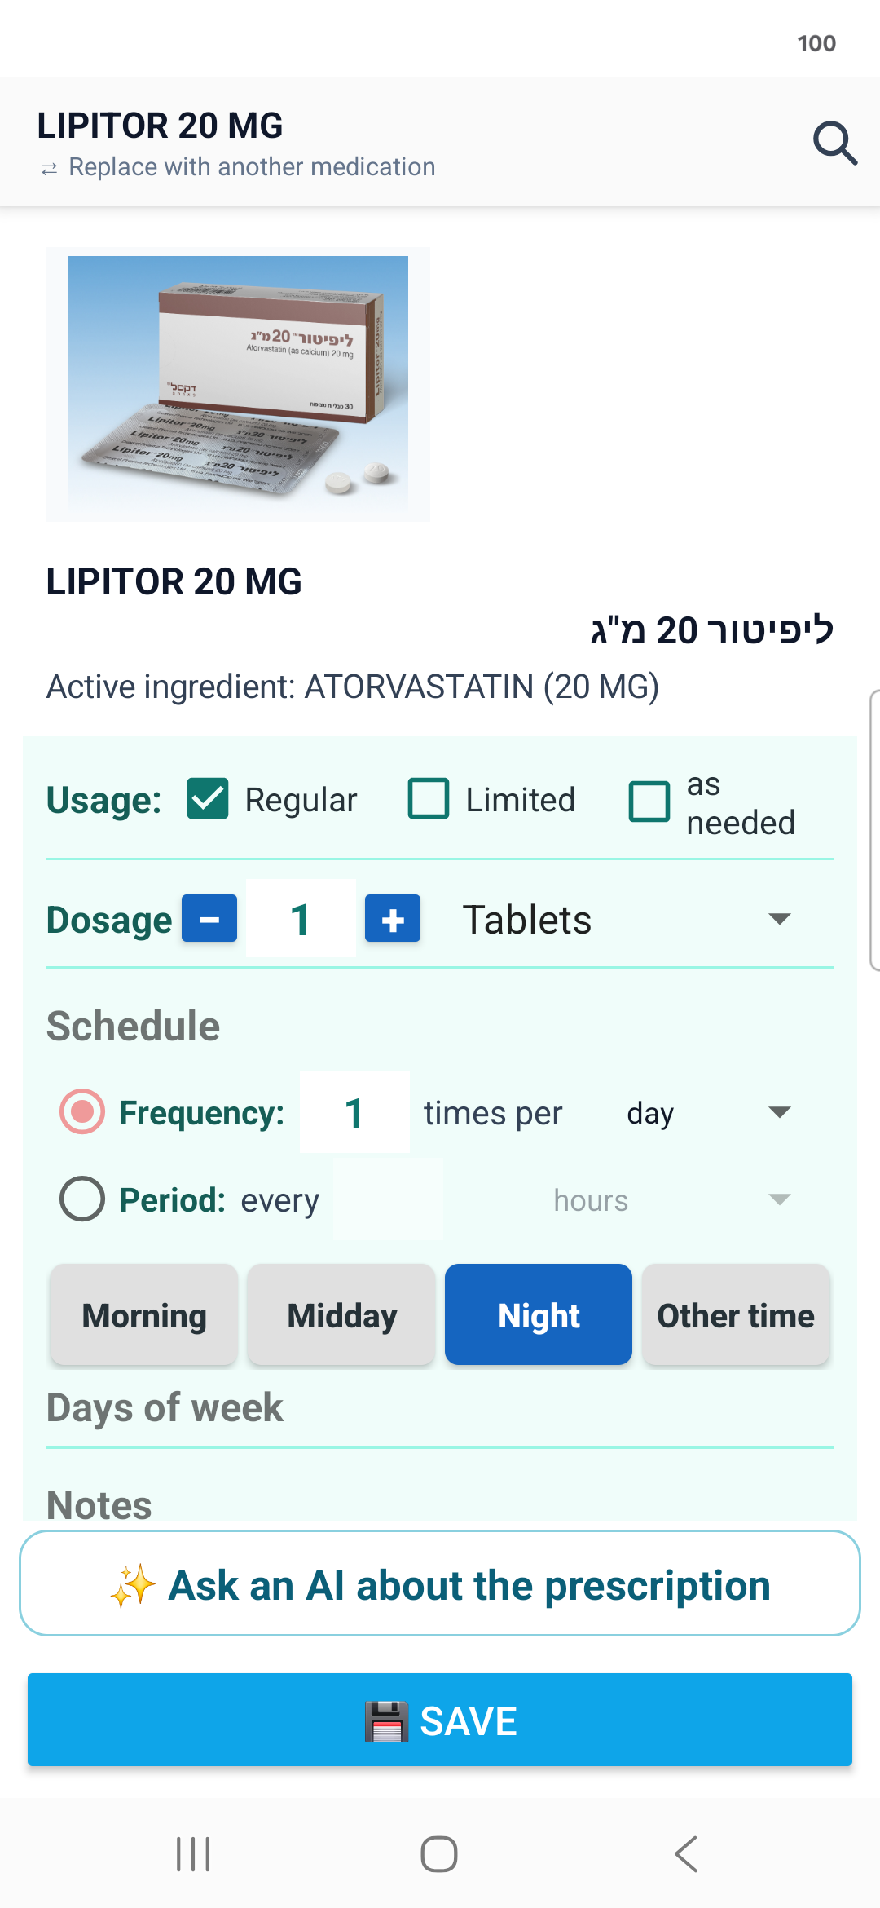

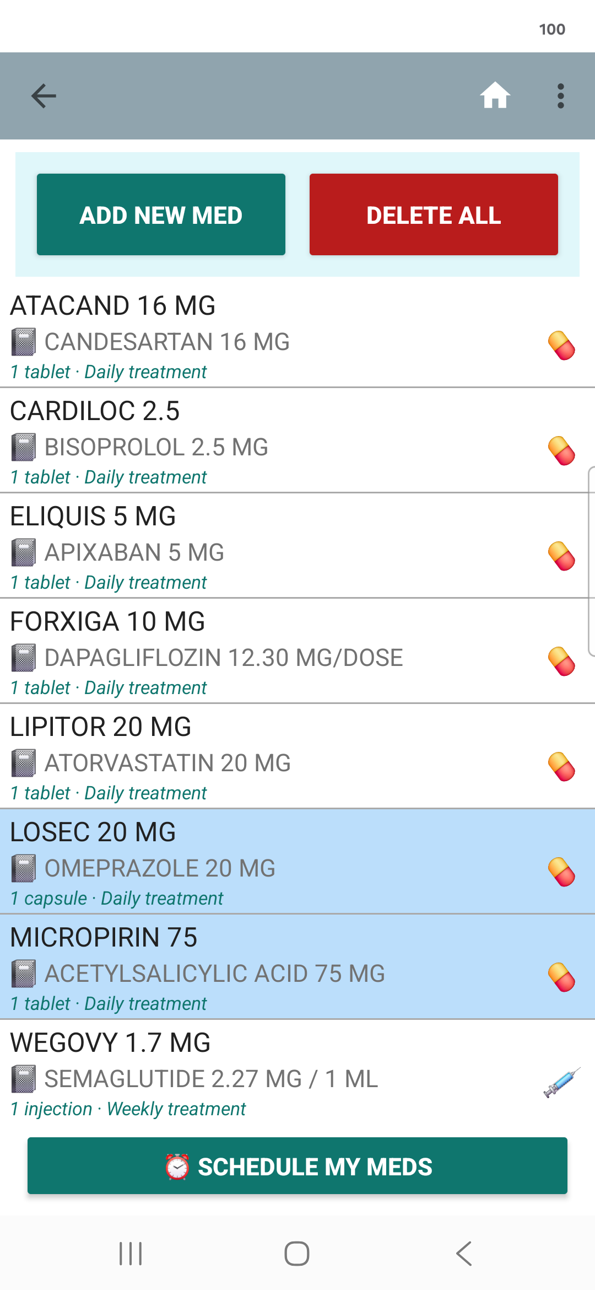 | 5. Manage My Meds  The My Meds screen keeps your personal medication list. You can edit, add, or delete medications from your meds, display and export the list, and print it.

6. Choose when and how to receive notifications  Use the scheduler to define which medication you want to be reminded of taking and at what time, so that it matches your daily routine. | 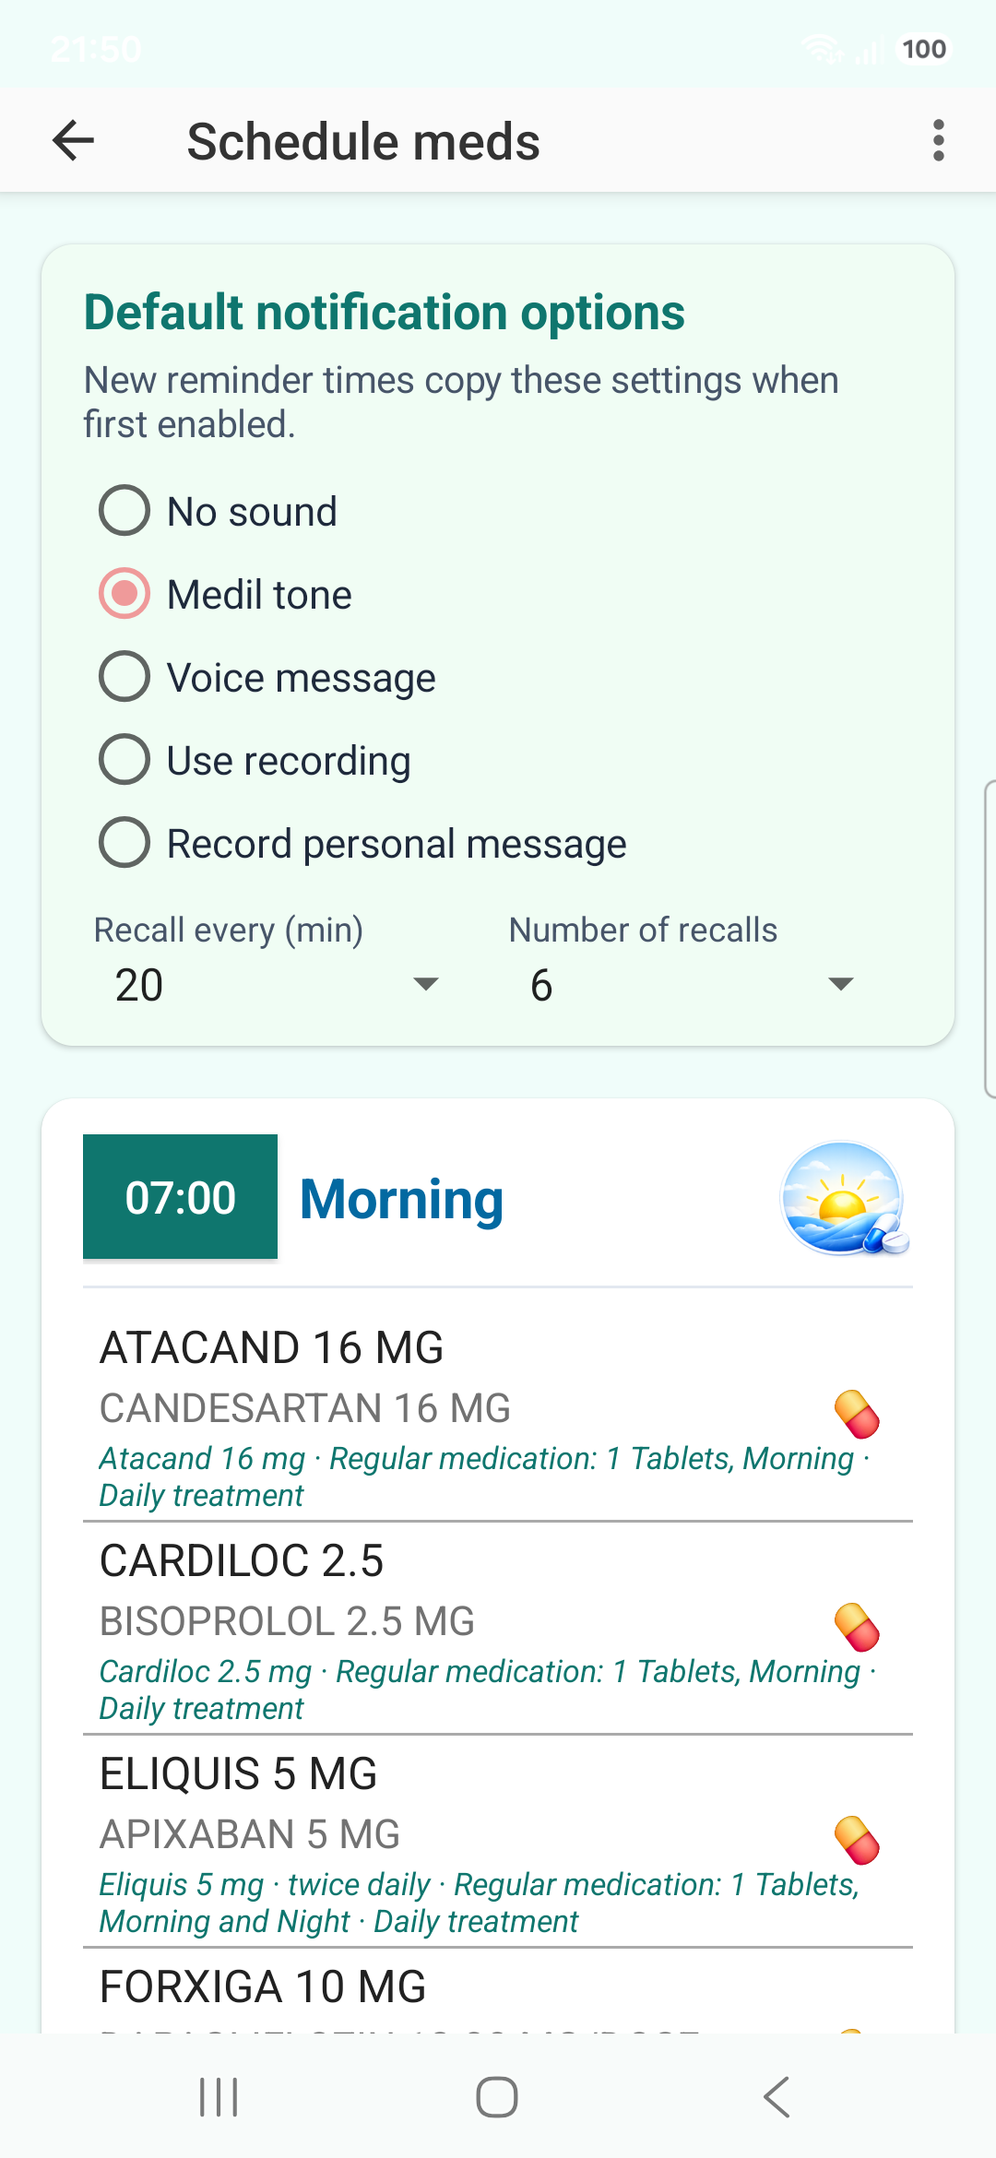

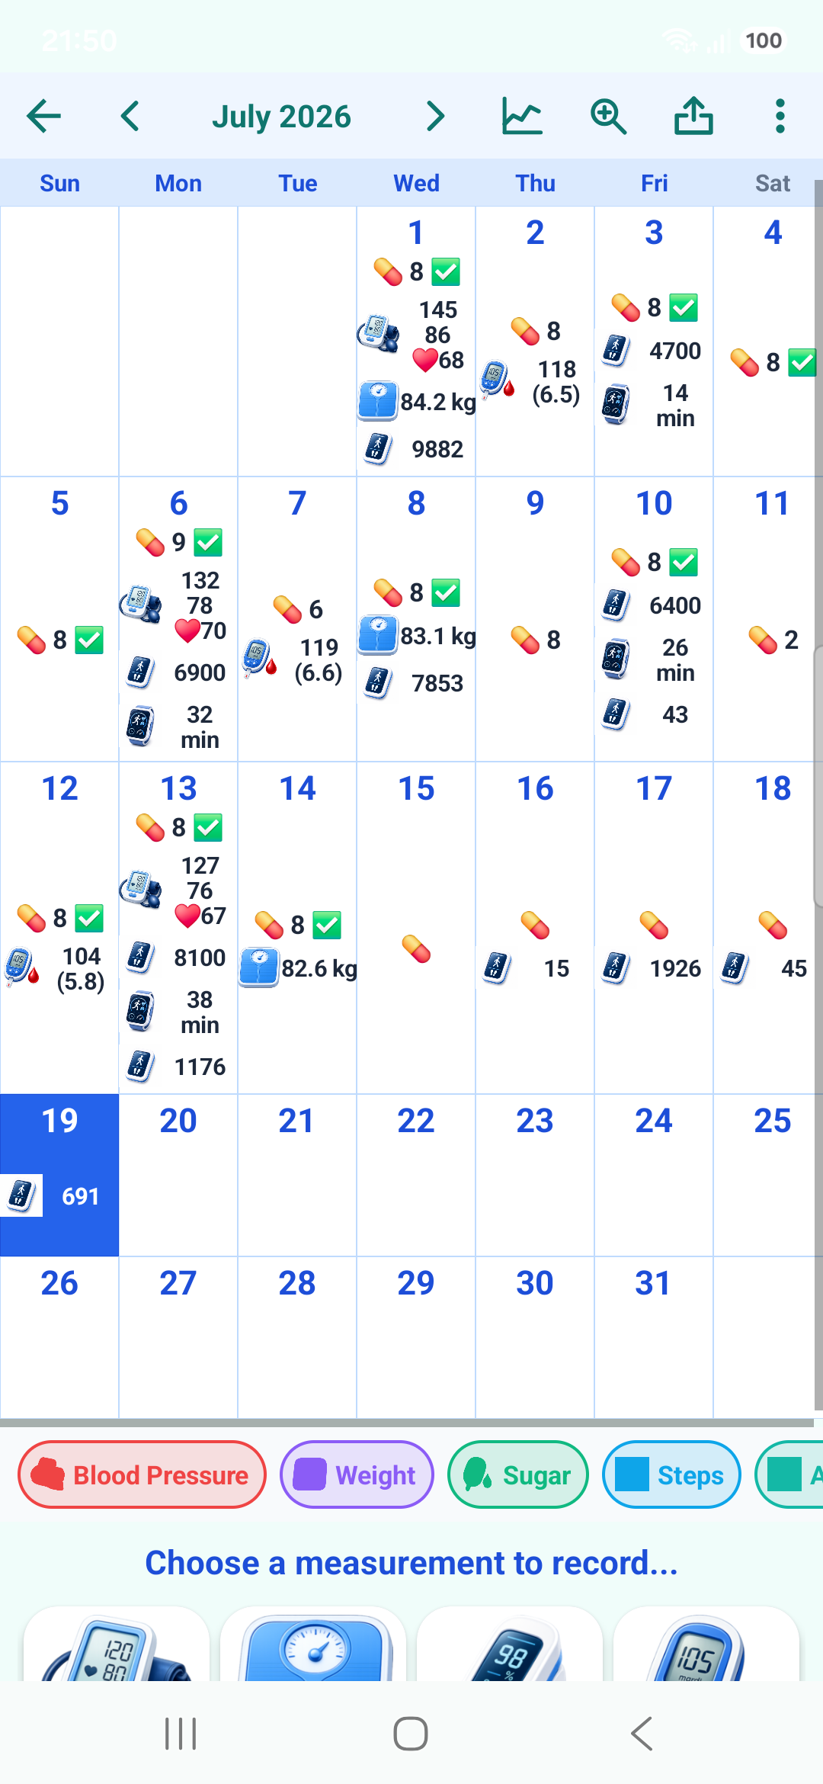 | 7. Review the diary calendar  Consult your medication uptake history in the calendar alongside health measurements automatically synchronized through Google Health Connect or Apple HealthKit, including steps, aerobic activity, weight, glucose, and blood pressure. You can also enter your own measurements manually, view them in the calendar, print the record, and export the data to a file.

8. Compare trends with medication uptake  Chart mode shows sparse health measurements together with the medication uptake trace, helping patients and clinicians see timing relationships. | 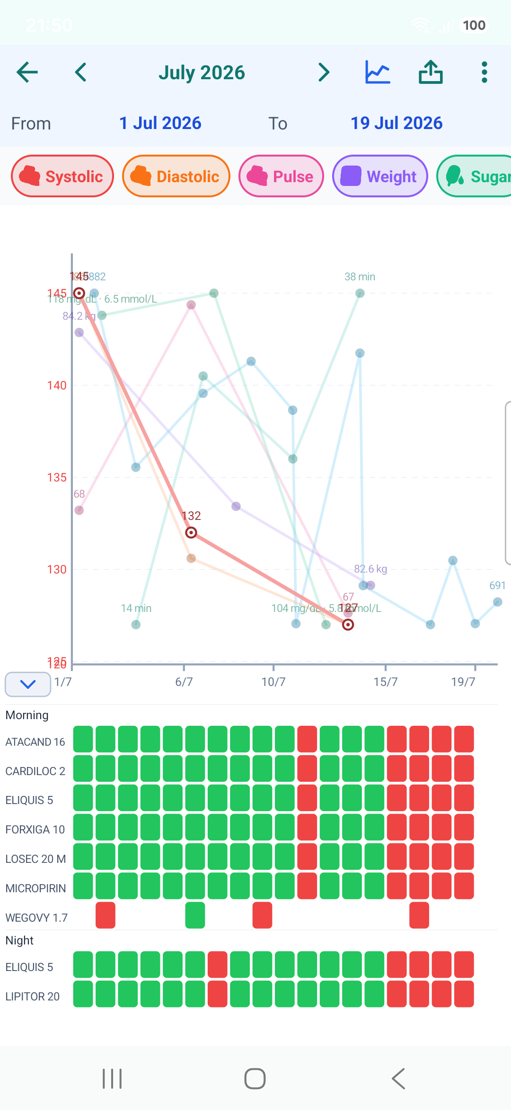

What is free, and what is Medil AI+
Free, always
Everything you need to know and organize your medications stays free: medication search and medication pages, My Meds, dose scheduling and reminders, intake tracking, and the health diary.

Medil AI+
The Plus subscription adds barcode scanning and the AI capabilities: prescription reading with AI, plain-language AI summaries and translations, sending a question to the AI assistant of your choice with your context, automatic Health Connect import, and export and printing of your lists and diary.

Every new user receives Medil AI+ free for the first 14 days — no commitment. Afterwards, the free features remain free, always.

